MATH 243 — Probability and Statistics
Correlation and Regression Analysis
Lesson notes · Exam approach · TF practice with solutions · Quick notes (Statistics portion)

How to Read These Notes
EXAM FOCUS | Exam importance, where it appears in the TF collection
MEMORIZE | Rules, tables and formulas to memorize
TRAP | Common mistakes and exam traps
EXAM-READY ANSWER | Model wording you can write in the exam
NOTE | Extra explanation / clarification
Grey box, monospace | Code, worked tables, derivations and hand-drawn sketches
Centered grey box | Formula to remember / final numerical result
Purple heading / ✔ green | Practice questions / their solutions

Contents
Exam Map — What the TF Papers Ask — a regression question in every paper
Lesson 12 — Correlation, Scatter Diagram and Pearson's r — types, interpretation, −1 ≤ r ≤ 1
Lesson 13 — Spearman's Rank Correlation (with Ties) — D², tie correction
Lesson 14 — The Two Regression Lines — least squares, b_yx, b_xy, estimates, all TF tables
Lesson 15 — Goodness of Fit (R²), Polynomial and Multiple Regression — SST = SSR + SSE, quadratic fit
Quick Notes — Correlation and Regression — revision bullets
NOTE Page numbers refer to 7. Correlation and regression analysis.pdf (17 pp.), written as p. n. Notation: S_xx = Σx² − (Σx)²/n, S_yy = Σy² − (Σy)²/n, S_xy = Σxy − ΣxΣy/n. "TF p." = merged question PDF page; "22 batch p." = 2023-24 paper.

Exam Map — What the TF Papers Ask
Session (paper) | Questions answered by this note [lesson]
2023-24 (MATH 243)  TF p. 22 batch p.2, 22 batch p.3 | Q4(b) Pearson's r; rank correlation with repeated ranks — sales and expenses of 10 stores (12) [L13] · Q4(c) Objectives of correlation/regression; second-degree polynomial for nitrogen vs yield; coefficient of determination (12) [L15] · Q5(b) Scatter plot of price vs rating for 5 restaurants; is there a relationship? (13) [L12]
2022-23 (MATH 243)  TF p. 48, 49 | Q4(b) Correlation vs regression; rank correlation, Bangla vs English marks of 8 applicants (ties) (12) [L13] · Q4(c) Ages of 10 husbands and wives: two regression equations; husband at wife 30, wife at husband 25; comment on r (13) [L14]
2021-22 (MATH 245)  TF p. 44–45 | Q7(a) Loblolly pines (15): specific gravity vs modulus of rupture — both regression coefficients; r and interpretation (20) [L14]
2020-21 (MATH 245)  TF p. 37 | Q6(a) Experience X vs rating Y (5 persons): fit Y on X; SSR and SST (15) [L15]
2019-20 (MATH 245)  TF p. 34 | Q6(a) Distance to transmitter vs signal strength (10 pairs): regression of Y on X; predict at 10 m (17) [L14]
2018-19 (MATH 245)  TF p. 24 | Q6(a) Regression of capacity utilisation on production from means, SDs and r = 0.62; production when capacity is 70 (20) [L14]
2016-17 (MATH 245)  TF p. 20 | Q6(b) Experience X vs rating Y (5 persons): fit Y on X; SSR, SST; is the linear model adequate (R²)? (18) [L15]
2015-16 (MATH 241)  TF p. 16 | Q7(b) Years of service vs income (9 persons): regression equations, r; starting income for 15 years' service (17) [L14]
2014-15 (MATH 241)  TF p. 11 | Q7(a) Regression lines Y on X and X on Y and r (7 pairs, X 42…66, Y 56…51) (20) [L14]
2013-14 (MATH 241)  TF p. 8 | Q7(a) Ages of husbands and wives (8 couples): two regression equations, r; husband's age when wife is 24 (20) [L14]
2012-13 (MATH 241)  TF p. 5 | Q7(a) Economics vs Business marks (10 students): two regression equations and coefficients; estimates; comment on r (18) [L14]
2011-12 (MATH 241)  TF p. 2 | Q7(a) Two regression lines and r from 9 (X, Y) pairs (X 105…111, Y 58…55) (20) [L14]

EXAM FOCUS 15 questions, 247 marks — the largest Statistics topic, in every paper. Nine of them are the same task: from paired data find both regression lines, r and an estimate. Since 2016-17 the papers add SSR/SST/R² adequacy, rank correlation with ties (2022-23, 2023-24) and a second-degree polynomial (2023-24). Learn the S_xx, S_yy, S_xy table — it gives every answer.

Lesson 12 — Correlation, Scatter Diagram and Pearson's r
pp. 1–5
Correlation analysis measures the strength (degree) of the relationship between variables (fertiliser and rice production, height and weight). Positive: both increase together; negative: one increases as the other decreases; perfect: the ratio of changes is constant (p. 1). Types: positive/negative, simple/multiple, linear/non-linear.
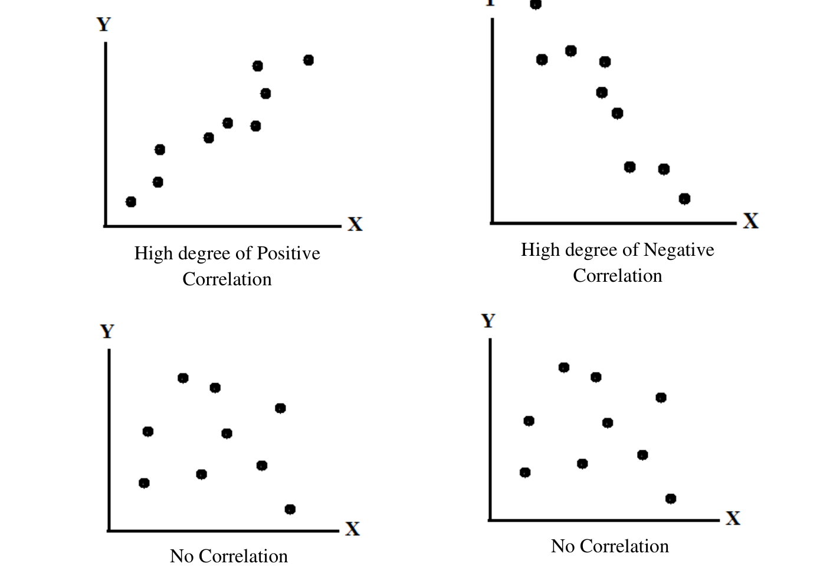
Figure 12.1 — Scatter diagrams: high positive, high negative and no correlation (p. 2)
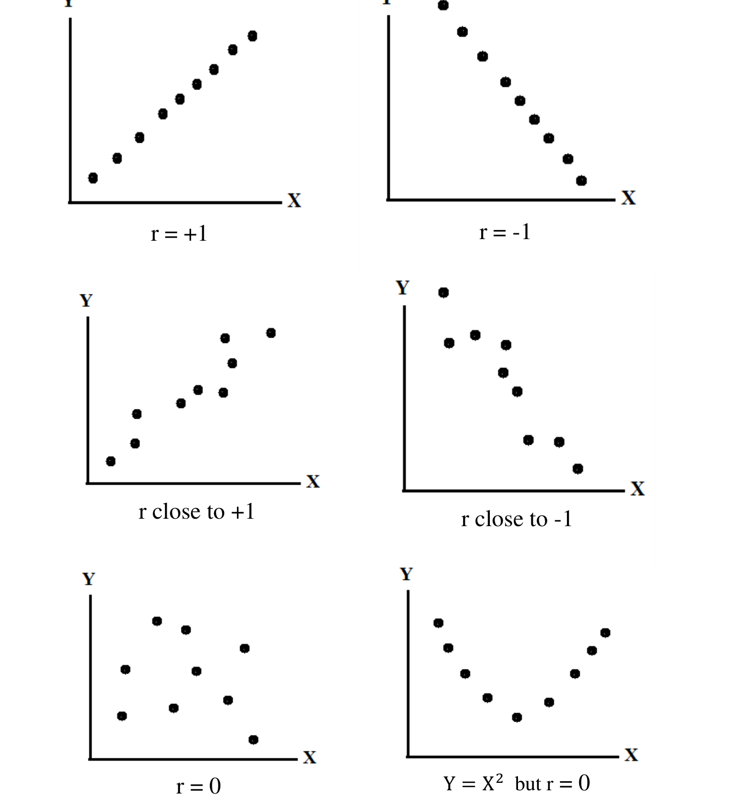
Figure 12.2 — r = ±1, r close to ±1, r = 0, and Y = X² with r = 0 (p. 3)
r = Σ(x − x̄)(y − ȳ) / √[Σ(x − x̄)² Σ(y − ȳ)²] = S_{xy}/√(S_{xx}S_{yy})
- −1 ≤ r ≤ 1. r = +1 / −1: perfect positive / negative linear relation.
- r near ±1: strong linear relation; near 0: weak linear relation. r = 0 does not mean "no relation" — the relation may be curved (p. 3).

Proof that −1 ≤ r ≤ 1 (p. 5)
Let u = (x − x̄)/√Σ(x − x̄)², v = (y − ȳ)/√Σ(y − ȳ)², so Σu² = Σv² = 1 and Σuv = r.
0 ≤ Σ(u + v)² = Σu² + Σv² + 2Σuv = 2 + 2r ⟹ r ≥ −1
0 ≤ Σ(u − v)² = 2 − 2r ⟹ r ≤ 1

Sales vs expenses of 10 firms (p. 4): Σ(x − x̄)² = 360, Σ(y − ȳ)² = 22, Σ(x − x̄)(y − ȳ) = 70 → r = 70/√(360 × 22) = 0.7866, a fairly high positive correlation. Advertising vs sales: r = 0.865.

Practice — Lesson 12
(a) Actual — 2023-24 Q5(b) (22 batch p. 3) — the plot is drawn in the Intro & Graphs note, Lesson 3.
(a) Prices ($) and ratings of 5 restaurants: (22, 3.5), (29, 4.0), (15, 3.0), (18, 4.0), (23, 3.5). Draw the scatter plot and interpret whether price and rating are related. (13)

✔ Solution
Σx = 107, Σy = 18, Σx² = 2403, Σy² = 65.5, Σxy = 390.5
S_xx = 2403 − 107²/5 = 113.2; S_yy = 65.5 − 18²/5 = 0.7; S_xy = 390.5 − 107×18/5 = 5.3
r = 5.3/√(113.2 × 0.7) = 0.595

The points drift upward with one exception (D): a moderate positive relationship (r ≈ 0.60) — higher prices tend to go with higher ratings, but with five restaurants the evidence is weak.

Lesson 13 — Spearman's Rank Correlation (with Ties)
pp. 5–7
Used when only ranks are available or the characteristic cannot be measured exactly (sincerity, honesty).
r_{s} = 1 − 6ΣD² / [n(n² − 1)]
Ties: r_{s} = 1 − 6[ΣD² + Σ(m³ − m)/12] / [n(n² − 1)]
D = difference between the two ranks; tied values get the average of the ranks they occupy; m = number of times a value is repeated (one correction term per tied group, in either series). Managers: ΣD² = 14 → r_{s} = 1 − 84/990 = 0.915 (high agreement). Tests: ΣD² = 44 → r_{s} = 0.733.

Exam Approach
1. Rank each series separately (largest = highest rank or smallest = 1 — same convention for both).
2. Average ranks for ties; list D and D²; add the (m³ − m)/12 corrections.
3. Substitute; interpret sign and size.

Practice — Lesson 13
(a) Actual — 2022-23 Q4(b) (TF p. 48). (b) Actual — 2023-24 Q4(b) (22 batch p. 2).
(a) Distinguish clearly between correlation and regression analysis. Marks of 8 applicants — Bangla: 15, 20, 28, 12, 40, 60, 20, 80; English: 40, 30, 50, 30, 20, 10, 30, 60. Compute the rank correlation coefficient and comment. (12)
(b) What is Pearson's correlation coefficient? How do you modify the rank formula when observations are repeated? Hourly sales x: 50, 50, 55, 60, 65, 65, 65, 60, 60, 60 and expenses y: 11, 13, 14, 16, 16, 15, 15, 14, 13, 13 of 10 stores: calculate the rank correlation coefficient. (12)

✔ Solution
EXAM-READY ANSWER Correlation vs regression (p. 14): correlation measures the degree and direction of association and treats X and Y symmetrically (r_{xy} = r_{yx}, unit-free, −1 to 1); regression expresses the average dependence of a dependent variable on independent variable(s) through an equation, treats them asymmetrically (b_{yx} ≠ b_{xy}, in units of the data) and is used to predict. Correlation does not imply causation; regression assumes a direction of dependence.

(a) Ranks (1 = smallest).
Applicant | Bangla | R_B | English | R_E | D | D²
A | 15 | 2 | 40 | 6 | −4 | 16
B | 20 | 3.5 | 30 | 4 | −0.5 | 0.25
C | 28 | 5 | 50 | 7 | −2 | 4
D | 12 | 1 | 30 | 4 | −3 | 9
E | 40 | 6 | 20 | 2 | 4 | 16
F | 60 | 7 | 10 | 1 | 6 | 36
G | 20 | 3.5 | 30 | 4 | −0.5 | 0.25
H | 80 | 8 | 60 | 8 | 0 | 0
Total |  |  |  |  | 0 | 81.5

Ties: Bangla 20 twice (m = 2): (2³ − 2)/12 = 0.5; English 30 three times (m = 3): (3³ − 3)/12 = 2
r_s = 1 − 6(81.5 + 0.5 + 2)/[8(64 − 1)] = 1 − 504/504 = 0

r_{s} = 0: no association between the rankings in Bangla and English. (The slide on p. 7 uses the same data.)
(b) Pearson's r: §L12. Modified formula: add Σ(m³ − m)/12 to ΣD² for every tied group.
x | R_x | y | R_y | D²
50 | 1.5 | 11 | 1 | 0.25
50 | 1.5 | 13 | 3 | 2.25
55 | 3 | 14 | 5.5 | 6.25
60 | 5.5 | 16 | 9.5 | 16
65 | 9 | 16 | 9.5 | 0.25
65 | 9 | 15 | 7.5 | 2.25
65 | 9 | 15 | 7.5 | 2.25
60 | 5.5 | 14 | 5.5 | 0
60 | 5.5 | 13 | 3 | 6.25
60 | 5.5 | 13 | 3 | 6.25

ΣD² = 42. Ties in x: 50 (m = 2), 60 (m = 4), 65 (m = 3); in y: 13 (m = 3), 14 (m = 2), 15 (m = 2), 16 (m = 2)
Σ(m³ − m)/12 = 0.5 + 5 + 2 + 2 + 0.5 + 0.5 + 0.5 = 11
r_s = 1 − 6(42 + 11)/[10(100 − 1)] = 0.6788

A fairly high positive rank correlation (0.68): stores with higher sales tend to have higher expenses.
NOTE The paper prints the last sales value as 60; the slide (p. 4) has 50 for firm 10. With the slide's data r_s = 0.7515 and Pearson r = 0.787. Use the paper's numbers in the exam.

Lesson 14 — The Two Regression Lines
pp. 8–12
Regression studies the dependence of a dependent variable on independent variable(s), to estimate or predict its average value. Objectives (p. 9): estimate the average relationship; find the effect of each independent variable; predict the dependent variable. A deterministic relation is exact; a non-deterministic one has random error ε.
Y on X: ŷ = a + b_{yx}x, b_{yx} = [nΣxy − ΣxΣy]/[nΣx² − (Σx)²] = S_{xy}/S_{xx}, a = ȳ − b_{yx}x̄
X on Y: x̂ = a' + b_{xy}y, b_{xy} = S_{xy}/S_{yy}, a' = x̄ − b_{xy}ȳ
r = ±√(b_{yx}b_{xy}); b_{yx} = r σ_{y}/σ_{x}, b_{xy} = r σ_{x}/σ_{y}
Least squares (p. 10): choose a, b to minimise SSE = Σ(y − a − bx)²; ∂SSE/∂a = 0 and ∂SSE/∂b = 0 give the normal equations Σy = na + bΣx and Σxy = aΣx + bΣx².
Transmitter example (p. 11): Σx = 118, Σy = 336.6, Σx² = 1708, Σxy = 3834.3 → b = (10×3834.3 − 118×336.6)/(10×1708 − 118²) = −0.4359, a = 38.804; ŷ = 38.804 − 0.4359x; at 10 m ŷ = 34.44 dB.
MEMORIZE Use the line of the variable you want to estimate: estimate y from x with Y on X; estimate x from y with X on Y. Both lines pass through (x̄, ȳ); r has the sign of the b's.

Exam Approach
1. Table of x, y, x², y², xy (or deviations); totals; x̄, ȳ.
2. S_xx, S_yy, S_xy; b_yx = S_xy/S_xx, b_xy = S_xy/S_yy; intercepts from the means.
3. r = S_xy/√(S_xx S_yy) (check r² = b_yx b_xy); interpret.
4. Estimates from the correct line; state units.

Practice — Lesson 14
(a) Actual — 2022-23 Q4(c) (TF p. 49). (b) Actual — 2019-20 Q6(a) (TF p. 34). (c) Actual — 2018-19 Q6(a) (TF p. 24). (d) Actual — 2021-22 Q7(a) (TF pp. 44–45). (e) Actual — 2015-16 Q7(b) (TF p. 16). (f) Actual — 2014-15 Q7(a) (TF p. 11). (g) Actual — 2013-14 Q7(a) (TF p. 8). (h) Actual — 2012-13 Q7(a) (TF p. 5). (i) Actual — 2011-12 Q7(a) (TF p. 2).
(a) Ages of husbands 22, 23, 23, 24, 26, 27, 27, 28, 30, 30 and wives 18, 20, 21, 20, 21, 22, 23, 24, 25, 26: the two regression equations; husband's age when the wife is 30; wife's age when the husband is 25; comment on r. (13)
(b) Distance to transmitter X: 13, 12, 17, 19, 14, 15, 15, 8, 13, 3 and signal strength Y: 34.4, 38.4, 30.4, 29.7, 30.1, 33.9, 32.8, 35.2, 34.9, 36.8. Regression line of Y on X; predict Y at 10 m. (17)
(c) Production: mean 35.6, SD 10.5; capacity utilisation: mean 84.8, SD 8.5; r = 0.62. Regression of capacity utilisation on production; estimate production when capacity utilisation is 70 %. (20)
(d) Specific gravity x and modulus of rupture y of 15 loblolly pines (TF p. 45): both regression coefficients; compute and interpret r. (20)
(e) Years of service 10, 8, 9, 5, 7, 6, 12, 11, 13 and income ('000) 17, 12, 14, 8, 10, 9, 20, 18, 22: regression equations and r; starting income for 15 years' experience. (17)
(f) X: 42, 44, 58, 55, 89, 98, 66; Y: 56, 49, 53, 58, 65, 76, 51 — regression lines Y on X and X on Y; r. (20)
(g) Husbands 22, 25, 28, 31, 35, 32, 37, 39; wives 19, 18, 22, 29, 31, 23, 30, 33: regression equations, r; most likely age of husband when the wife is 24. (20)
(h) Economics 47, 38, 34, 44, 32, 41, 35, 32, 42, 30; Business 38, 34, 42, 39, 34, 33, 30, 41, 38, 28: regression equations and coefficients; Economics when Business = 36; Business when Economics = 44; comment on r. (18)
(i) X: 105, 112, 104, 114, 117, 108, 106, 117, 111; Y: 58, 56, 47, 46, 51, 64, 66, 50, 55 — two regression lines, r. (20)

✔ Solution
(a) Let x = husband's age, y = wife's age; n = 10.
Σx = 260, Σy = 220, Σx² = 6836, Σy² = 4896, Σxy = 5782; x̄ = 26, ȳ = 22
S_xx = 76, S_yy = 56, S_xy = 62
b_yx = 62/76 = 0.8158; Y on X: ŷ = 0.7895 + (0.8158)x
b_xy = 62/56 = 1.1071; X on Y: x̂ = 1.6429 + (1.1071)y
r = 62/√(76 × 56) = 0.9504 (check √(b_yx b_xy) = 0.9504)
Husband at wife = 30: x̂ = 1.6429 + 1.1071(30) = 34.86 years
Wife at husband = 25: ŷ = 0.7895 + 0.8158(25) = 21.18 years

r = 0.95: very high positive correlation — older husbands have older wives.
(b) Let x = distance (m), y = signal (dB); n = 10.
Σx = 129, Σy = 336.6, Σx² = 1851, Σy² = 11406.52, Σxy = 4256.7; x̄ = 12.9, ȳ = 33.66
S_xx = 186.9, S_yy = 76.564, S_xy = −85.44
b_yx = −85.44/186.9 = −0.4571; Y on X: ŷ = 39.5571 + (−0.4571)x
b_xy = −85.44/76.564 = −1.1159; X on Y: x̂ = 50.4622 + (−1.1159)y
r = −85.44/√(186.9 × 76.564) = −0.7142 (check √(b_yx b_xy) = 0.7142)
At x = 10: ŷ = 39.5571 − 0.4571(10) = 34.99 dB

Signal strength falls about 0.46 dB per metre. (With the slide's value 1 instead of 12 for the second distance the line is ŷ = 38.804 − 0.4359x and the prediction 34.44 dB.)
(c) x = production, y = capacity utilisation.
b_yx = r σ_y/σ_x = 0.62 × 8.5/10.5 = 0.5019; y − 84.8 = 0.5019(x − 35.6) → ŷ = 66.9322 + 0.5019x
b_xy = r σ_x/σ_y = 0.62 × 10.5/8.5 = 0.7659; x − 35.6 = 0.7659(y − 84.8) → x̂ = −29.3468 + 0.7659y
Production when y = 70: x̂ = 35.6 + 0.7659(70 − 84.8) = 24.26

(d) Let x = specific gravity (g/cm³), y = modulus of rupture (kPa); n = 15.
Σx = 7.296, Σy = 788,510, Σx² = 3.6201, Σy² = 47,598,707,772, Σxy = 403686.826; x̄ = 0.4864, ȳ = 52567.3333
S_xx = 0.0714, S_yy = 6148839765.3333, S_xy = 20155.562
b_yx = 20155.562/0.0714 = 282458.5188; Y on X: ŷ = −84820.4902 + (282458.5188)x
b_xy = 20155.562/6148839765.3333 = 0; X on Y: x̂ = 0.3141 + (0)y
r = 20155.562/√(0.0714 × 6148839765.3333) = 0.9622 (check √(b_yx b_xy) = 0.9622)

b_yx ≈ 282,459 kPa per g/cm³ (an increase of 0.01 in specific gravity raises the modulus by about 2,825 kPa); b_xy ≈ 3.28 × 10⁻⁶ g/cm³ per kPa. r = 0.962: a very strong positive linear relationship — denser wood is stronger; r² = 0.926, so 92.6 % of the variation in modulus of rupture is explained by specific gravity.
(e) Let x = years of service, y = income ('000); n = 9.
Σx = 81, Σy = 130, Σx² = 789, Σy² = 2082, Σxy = 1280; x̄ = 9, ȳ = 14.4444
S_xx = 60, S_yy = 204.2222, S_xy = 110
b_yx = 110/60 = 1.8333; Y on X: ŷ = −2.0556 + (1.8333)x
b_xy = 110/204.2222 = 0.5386; X on Y: x̂ = 1.2198 + (0.5386)y
r = 110/√(60 × 204.2222) = 0.9937 (check √(b_yx b_xy) = 0.9937)
At x = 15: ŷ = −2.0556 + 1.8333(15) = 25.44 thousand

r = 0.994: almost perfect positive correlation; recommend a starting income of about Tk 25,440.
(f) Let x = X, y = Y; n = 7.
Σx = 452, Σy = 408, Σx² = 31,970, Σy² = 24,312, Σxy = 27,371; x̄ = 64.5714, ȳ = 58.2857
S_xx = 2783.7143, S_yy = 531.4286, S_xy = 1025.8571
b_yx = 1025.8571/2783.7143 = 0.3685; Y on X: ŷ = 34.4898 + (0.3685)x
b_xy = 1025.8571/531.4286 = 1.9304; X on Y: x̂ = −47.9419 + (1.9304)y
r = 1025.8571/√(2783.7143 × 531.4286) = 0.8434 (check √(b_yx b_xy) = 0.8434)

r = 0.84: high positive correlation.
(g) Let x = husband's age, y = wife's age; n = 8.
Σx = 249, Σy = 205, Σx² = 7993, Σy² = 5489, Σxy = 6601; x̄ = 31.125, ȳ = 25.625
S_xx = 242.875, S_yy = 235.875, S_xy = 220.375
b_yx = 220.375/242.875 = 0.9074; Y on X: ŷ = −2.6166 + (0.9074)x
b_xy = 220.375/235.875 = 0.9343; X on Y: x̂ = 7.1839 + (0.9343)y
r = 220.375/√(242.875 × 235.875) = 0.9207 (check √(b_yx b_xy) = 0.9207)
Husband at wife = 24: x̂ = 7.1839 + 0.9343(24) = 29.61 years

r = 0.92: high positive correlation.
(h) Let x = Economics, y = Business; n = 10.
Σx = 375, Σy = 357, Σx² = 14,363, Σy² = 12,939, Σxy = 13,461; x̄ = 37.5, ȳ = 35.7
S_xx = 300.5, S_yy = 194.1, S_xy = 73.5
b_yx = 73.5/300.5 = 0.2446; Y on X: ŷ = 26.5278 + (0.2446)x
b_xy = 73.5/194.1 = 0.3787; X on Y: x̂ = 23.9815 + (0.3787)y
r = 73.5/√(300.5 × 194.1) = 0.3043 (check √(b_yx b_xy) = 0.3043)
Economics at Business = 36: x̂ = 23.9815 + 0.3787(36) = 37.61
Business at Economics = 44: ŷ = 26.5278 + 0.2446(44) = 37.29

Regression coefficients b_yx = 0.245, b_xy = 0.379; r = 0.30 — a weak positive correlation, so the estimates are not reliable.
(i) Let x = X, y = Y; n = 9.
Σx = 994, Σy = 493, Σx² = 109,980, Σy² = 27,403, Σxy = 54,324; x̄ = 110.4444, ȳ = 54.7778
S_xx = 198.2222, S_yy = 397.5556, S_xy = −125.1111
b_yx = −125.1111/198.2222 = −0.6312; Y on X: ŷ = 124.4865 + (−0.6312)x
b_xy = −125.1111/397.5556 = −0.3147; X on Y: x̂ = 127.6831 + (−0.3147)y
r = −125.1111/√(198.2222 × 397.5556) = −0.4457 (check √(b_yx b_xy) = 0.4457)

r = −0.45: moderate negative correlation.

Lesson 15 — Goodness of Fit (R²), Polynomial and Multiple Regression
pp. 12–17
SST = Σ(y − ȳ)² = SSR + SSE, SSR = Σ(ŷ − ȳ)², SSE = Σ(y − ŷ)²
R² = SSR/SST, 0 ≤ R² ≤ 1; simple linear: R² = r², SSR = b_{yx}S_{xy}
R² is the proportion (percentage) of the total variation in y explained by the regression. Close to 1 → the model fits well; deterministic relation → SSE = 0, R² = 1. Hardness vs tensile strength (p. 14): ŷ = 14.37 + 0.4167x, R² = 0.51 — only half the variation explained, so the linear model is not very adequate.

Multiple and Polynomial Regression (pp. 14–17)
ŷ = b₀ + b₁x₁ + b₂x₂: Σy = nb₀ + b₁Σx₁ + b₂Σx₂, Σx₁y = b₀Σx₁ + b₁Σx₁² + b₂Σx₁x₂, Σx₂y = …
ŷ = a + bx + cx²: treat x as x₁ and x² as x₂
Rice (p. 15): rainfall x₁, urea x₂: least squares gives ŷ = 27.355 − 0.6295x₁ − 0.0601x₂.

Exam Approach
1. Fit the line; ŷ for each x; SSR = Σ(ŷ − ȳ)² (or b S_xy), SST = S_yy, SSE = SST − SSR.
2. R² = SSR/SST; ≥ 0.8 adequate, around 0.5 or below doubtful.
3. Quadratic: compute Σx, Σx², Σx³, Σx⁴, Σy, Σxy, Σx²y; solve the three normal equations; R² = 1 − SSE/SST.

Practice — Lesson 15
(a) Actual — 2016-17 Q6(b) (TF p. 20) = 2020-21 Q6(a) (TF p. 37). (b) Actual — 2023-24 Q4(c) (22 batch p. 2).
(a) Experience X: 16, 12, 18, 4, 3 and performance rating Y: 87, 88, 89, 68, 58. (i) Fit a linear regression of Y on X. (ii) Find SSR and SST. (iii) Is the linear model appropriate? Justify with the coefficient of determination. (18)
(b) Briefly mention the objectives of correlation and regression analysis. Nitrogen doses x: 0, 1, 2, 3, 4, 5 (lb/acre) and yield y: 15, 25, 40, 55, 52, 43 (maunds/acre). Fit a second-degree polynomial and obtain the coefficient of determination. (12)

✔ Solution
Σx = 53, Σy = 390, Σx² = 749, Σxy = 4496, Σy² = 31222; x̄ = 10.6, ȳ = 78
S_xx = 749 − 53²/5 = 187.2; S_xy = 4496 − 53×390/5 = 362; S_yy = 31222 − 390²/5 = 802
(i) b = 362/187.2 = 1.9338; a = 78 − 1.9338 × 10.6 = 57.5021; ŷ = 57.5021 + 1.9338x
fitted ŷ: 88.44, 80.71, 92.31, 65.24, 63.3
(ii) SSR = Σ(ŷ − ȳ)² = b S_xy = 1.9338 × 362 = 700.02; SST = S_yy = 802
(iii) R² = SSR/SST = 700.02/802 = 0.8728

About 87 % of the variation in performance rating is explained by experience, so the linear model is appropriate (SSE = 101.98 is small relative to SST).
(b) Objectives: L14 (estimate the average relationship, measure the effect of each independent variable, predict). Normal equations for ŷ = a + bx + cx² (n = 6):
Σx = 15, Σx² = 55, Σx³ = 225, Σx⁴ = 979, Σy = 230, Σxy = 693, Σx²y = 2587
230 = 6a + 15b + 55c
693 = 15a + 55b + 225c
2587 = 55a + 225b + 979c
Solving: a = 11.5357, b = 21.6536, c = −2.9821
ŷ = 11.536 + 21.654x − 2.982x²
Fitted: 11.54, 30.21, 42.91, 49.66, 50.44, 45.25
SST = Σ(y − ȳ)² = 1211.33; SSE = Σ(y − ŷ)² = 83.66; R² = 1 − SSE/SST = 0.9309

R² = 0.931: the quadratic explains 93 % of the variation in yield. Yield is maximum near x = −b/(2c) = 3.63 lb/acre.
NOTE The slide (p. 17) uses the same data; its working table matches these sums.

Quick Notes — Correlation and Regression
Revision points for Lessons 12–15.

L12 · Pearson r
- r = S_xy/√(S_xx S_yy), −1 ≤ r ≤ 1 (proof with Σ(u ± v)² ≥ 0); r = 0 ≠ no relation.
- Sales/expenses r = 0.787; restaurants r = 0.60.

L13 · Rank Correlation
- r_s = 1 − 6[ΣD² + Σ(m³ − m)/12]/[n(n² − 1)].
- Bangla/English: ΣD² = 81.5, correction 2.5 → r_s = 0. Stores: r_s = 0.679 (paper data; 0.752 with the slide data).

L14 · Regression Lines
- b_yx = S_xy/S_xx, b_xy = S_xy/S_yy, lines through (x̄, ȳ); r² = b_yx b_xy.
- From summary data: b_yx = rσ_y/σ_x (capacity: ŷ = 66.93 + 0.502x; production at 70: 24.26).
- Husband/wife 2022-23: r = 0.95, 34.86 and 21.18. Service/income: 25.44. Transmitter (paper): 34.99 dB.

L15 · R² and Polynomial
- SST = SSR + SSE; R² = SSR/SST = r² for a line. Experience/rating R² = 0.873.
- Quadratic: three normal equations; nitrogen ŷ = 11.536 + 21.654x − 2.982x², R² = 0.931.

